Vince Tinto
Syracuse University, New York, USA

Promoting the Success of All Students: Lessons Learned from the United States
Professor Tinto will review what has been learned from thirty years of research, practice, and policy in the United States on how universities can best promote the success of the full range of the students they serve. In doing so, he will reflect on what the experience in the United States might mean for universities elsewhere that seek to promote the success of a more diverse student body. Among other things, he will speak to the importance of student classroom experience and in turn the types of pedagogies and assessment methods faculty employ in their teaching, and to the need for universities to build collaborative partnerships between faculty and support staff.

Biography
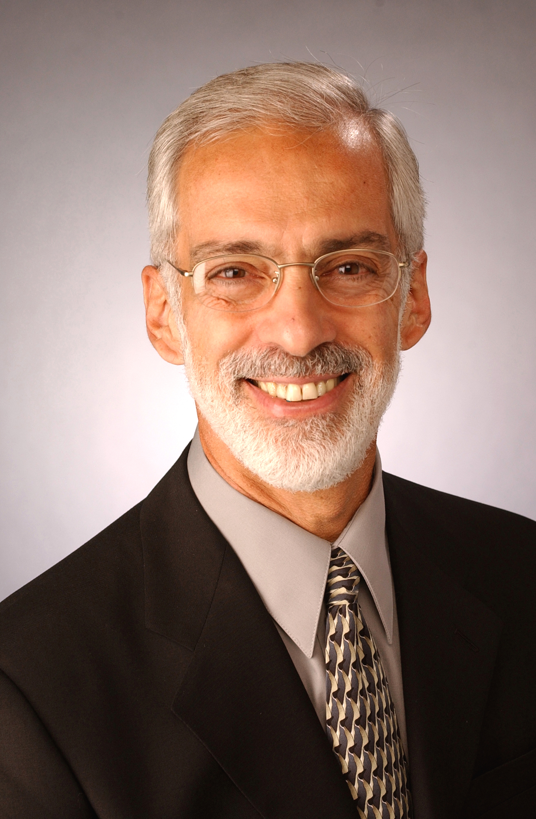
Professor Tinto received his Ph.D. in education and sociology from The University of Chicago. He is currently Distinguished University Professor at Syracuse University and chair of the higher education program. He has carried out research and has written extensively on higher education, particularly on student retention and the impact of learning communities on student growth and attainment. He has consulted widely with Federal and State agencies, with independent research firms, foundations, and with two and four-year institutions of higher education on a broad range of higher educational issues, not the least of which concern the retention and education of students in higher education. His current research, funded by a grant from the Lumina Foundation for Education, focuses on the impact of learning communities on the academic achievements of under-prepared college students in urban two and four-year colleges.

